Python Code
import requests
from bs4 import BeautifulSoup
import pandas as pd
import numpy as np
import matplotlib.pyplot as plt
import re

# Helper functions
def clean_text(text):
"""Cleans the given text by removing unwanted symbols.

Args:
text (str): The input text string.

Returns:
str or np.nan: The cleaned text string, or np.nan if the input text is None.
"""

if text:
# Remove leading and trailing spaces, parentheses, and newlines.
return text.strip(' ()').replace('\n', '').strip()
else:
# Return np.nan for None input
return np.nan

def extract_year(text):
"""Extracts the year from a given text string.

Args:
text (str): The input text string.

Returns:
int or nan: The extracted year as an integer, or NaN if no year is found.
"""

# Regular expression patterns to match different year formats
year_patterns = [
r"\b\d{4}\b", # Four digits alone (e.g., 2023)
r"\b(?:19|20)\d{2}\b", # Four digits starting with 19 or 20 (e.g., 1990, 2021)
r"\b(?:Jan|Feb|Mar|Apr|May|Jun|Jul|Aug|Sep|Oct|Nov|Dec)\s+\d{4}\b", # Month and year (e.g., Jan 2024)
r"\b\d{4}\s+(?:Jan|Feb|Mar|Apr|May|Jun|Jul|Aug|Sep|Oct|Nov|Dec)\b", # Year and month (e.g., 2023 Jan)
r"\b(?:\d{1,2}\s+)?(?:Jan|Feb|Mar|Apr|May|Jun|Jul|Aug|Sep|Oct|Nov|Dec)\s+\d{4}\b", # Day, month, and year (e.g., 25 Dec 2023)
]

for pattern in year_patterns:
match = re.search(pattern, text)
if match:
year_str = match.group()
try:
year = int(year_str)
if 1900 <= year <= 2100: # Ensure valid year range
return year
except ValueError:
pass # Ignore invalid year formats

return np.nan # No year found

# Q1 - On craigslist search for “Toyota Camry” and select search 100 miles from your location. (Using BU campus ZIP code)

url = "https://boston.craigslist.org/search/cta?postal=02215&query=toyota%20camry&search_distance=100#search=1~gallery~0~0"

# Q2 - Get the URL and utilize Beautiful Soup to build a data frame with the parsed data from your search.

def beautiful_soupify(url):
"""Fetches the HTML content of a given URL and parses it using BeautifulSoup.

Args:
url (str): The URL of the web page to fetch.

Returns:
BeautifulSoup object or None: The parsed BeautifulSoup object if the request is successful, or None if the request fails.
"""

# Send a GET request to the specified URL
response = requests.get(url)

# Check if the request was successful (status code 200)
if response.status_code == 200:
# Parse the HTML content using BeautifulSoup
soup = BeautifulSoup(response.content, 'html.parser')
return soup
else:
print("Connection request failed. Status code:", response.status_code)
return None # Return None to indicate a failed request

# Q3 - Your data frame should look like this example, with Description, Location, Price, and Year (when each data point is not available, use “null” numpy.nan).

def load_results(soup):
"""Extracts CraigsList listing information from a BeautifulSoup object.

Args:
soup (BeautifulSoup object): The parsed BeautifulSoup object containing the listing data.

Returns:
list: A list of dictionaries, each representing a listing with information like description, location, price, and year.
"""

listings = [] # Initialize an empty list to store the extracted listings

# Find all listing elements on the page
for result in soup.find_all('li', class_='cl-static-search-result'):
# Extract the description, location, and price information from each listing
description_tag = result.find('div', class_='title')
description = clean_text(description_tag.text) if description_tag else np.nan

location_tag = result.find('div', class_='location')
location = clean_text(location_tag.text) if location_tag else np.nan

price_tag = result.find('div', class_='price')
price = clean_text(price_tag.text) if price_tag else np.nan

# Convert the price to an integer, removing '$' and ','
if price != np.nan:
price = price.replace('$', '').replace(',', '')
try:
price = int(price)
except ValueError:
price = np.nan # If conversion fails, set to NaN

# Extract the year from the description
year = extract_year(description)

# Add the listing information to the list
listings.append({
'Description': description,
'Location': location,
'Price': price,
'Year': year
})

return listings

def create_df(listings):
"""Creates a pandas DataFrame from a list of listing dictionaries.

Args:
listings (list): A list of dictionaries, each representing a listing with information like description, location, price, and year.

Returns:
pandas.DataFrame: A DataFrame containing the listing data, with appropriate data types for price and year.
"""

# Create a DataFrame from the list of listings
df = pd.DataFrame(listings, columns=['Description', 'Location', 'Price', 'Year'])

# Convert the 'Price' and 'Year' columns to numeric, handling potential conversion errors
df['Price'] = pd.to_numeric(df['Price'], errors='coerce').astype('Int64')
df['Year'] = pd.to_numeric(df['Year'], errors='coerce').astype('Int64')

return df

soup = beautiful_soupify(url)

if soup:
listings = load_results(soup)

# Build DataFrame
df = create_df(listings)
print(df.head()) # Print first 5 results

# Q4 - Replace the missing values in “Year” column with the median value of the “Year” column.

df.fillna({'Year': df['Year'].median()}, inplace=True)

# Q5 - Plot the scatter plot for “Year” vs “Price”.

# Create the figure with desired size
fig, ax = plt.subplots(figsize=(16, 9))

# Scatter plot with transparency
ax.scatter(df['Year'], df['Price'], alpha=0.5)

# Set title, labels, and display the plot
ax.set_title('Craigslist Toyota Camry Price vs Model Year')
ax.set_xlabel('Year')
ax.set_ylabel('Price (in USD)')

# Save the figure as a PNG image
plt.savefig('craigslist_toyota_camry_price.png')

# Q6 - Get the Pearson Correlation between “Year” and “Price”.

pearson_corr = df['Year'].corr(df['Price'])
print(f'Pearson Correlation between “Year” and “Price”: {pearson_corr}')

Terminal Output
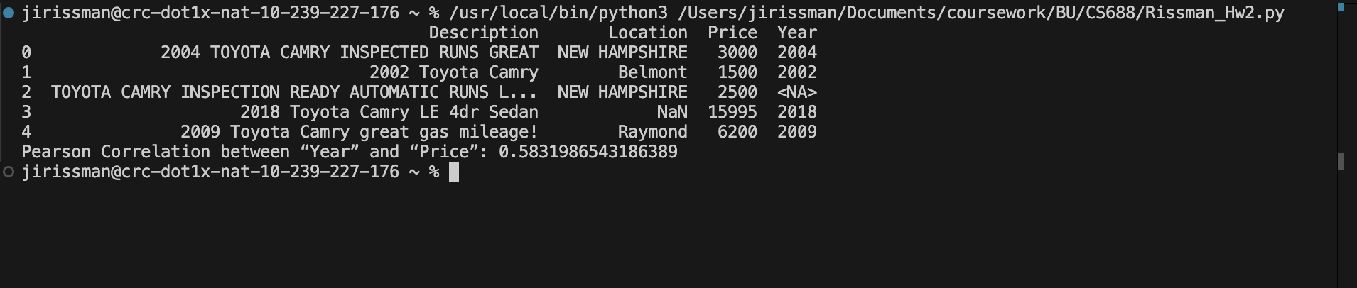
Scatter Plot
